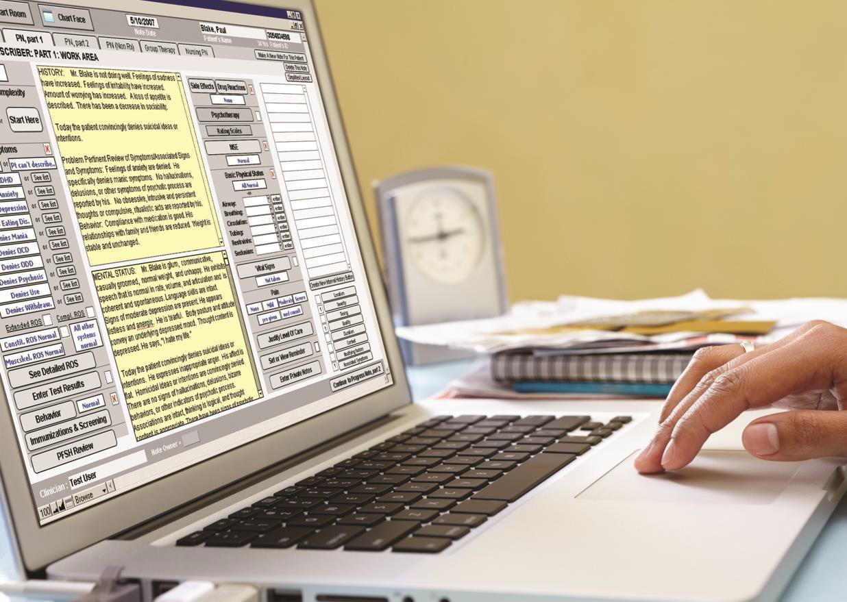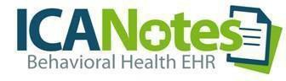

2024
Real World Test Plan Results

ICANotes LLC
01/15/2024

GENERAL INFORMATION

Plan Report ID Number: RWT Plan ICANotes - 10-31-2023

Developer Name: ICANotes, LLC

Product Name(s): ICANotes EHR/EMR for Behavioral Health

Version Number(s): 11.6, Edition 2015, Certification Date: 12/31/2018

Certified Health IT: 15.04.04.2755.ICAN.11.01.1.221224

Product List (CHPL) ID: 15.04.04.2755.ICAN.11.01.1.221224
Withdrawn Product: 15.04.04.1637.ICAN.11.00.1.181231

Real World Testing Plan URL: https://www.icanotes.com/features/onc-atcb-certification/

Real World Testing Results URL:
https://www.icanotes.com/wp-content/uploads/2024/01/2023-RWTP-Results-Report.pdf

JUSTIFICATION FOR REAL WORLD TESTING APPROACH

ICANotes is a medium-sized EHR founded in 1999 and designed by a psychiatrist to serve exclusively behavioral health providers. ICANotes serves those involved in behavioral health, including psychiatry, psychology, therapy, and addiction treatment. Currently certified for the 2015 Health Information Technology Edition, ICANotes uses a cloud-based solution. The majority of ICANotes customers provide outpatient services and receive referrals from other clinicians regularly.

ICANotes believes that a single Real-World Testing plan can address multiple certification criteria.

We will be utilizing real-time patient data and real-world production environments when implementing Real World Testing.

There might be a need to change our test methodology or approach based on what we found during our testing. During testing, this will only happen to accommodate unforeseen issues or problems that may arise. In these instances, a results report will document these types of changes, their reasons, and how intended outcomes were met more efficiently.

Testing will take place via Google Meets in the production environment using de-sensitized patient data. Demographic information will be altered to ensure HIPAA privacy regulations are met. An agency will be selected to send and receive transitions of care.
Testing will include the clinician or practice staff member, an ICANotes representative who interacts with the clinician, and an ICANotes observer who acts as a recorder. Development and QA staff will be on standby during the testing for assistance if needed.

ICANotes has been conducting real-world testing in 2024. We will submit the results of our testing by February 01, 2025.

MEASURES USED IN THE OVERALL APPROACH

ASSOCIATED CERTIFICATION CRITERIA
List certification criteria associated with the measure and if updated to the 2015 Edition Cures Update criteria.

Measurement/Metric | Associated Certification Criteria
Measure 1 | § 170.315(b)(1) Transitions of Care (Receive)
Measure 2 | § 170.315(b)(2) Clinical Information Reconciliation and Incorporation
Measure 3 | § 170.315(c)(1) Clinical Quality Measures Record and Export
Measure 4 | § 170.315(b)(1) Transitions of Care (Send)
Measure 5 | § 170.315(e)(1) View, Download and Transmit to 3rd party
Measures 6 - 8 | § 170.315(b)(6) Data Export
Measure 9 | § 170.315(g)(7) Application Access – Patient Selection
Measure 10 | § 170.315(g)(10) Application Access – Standardized API Criterion
Measure 11 | § 170.315(g)(9) Application Access – All Data Request

Measurement/Metric | Description
Measure 1:  The clinician logs into ICANotes and receives a CCDA from an external individual via Direct Protocol with no Tech Support and no errors. CCDA has demographic information adjusted so PHI is not visible.  Successful receipt of CCDA is achieved and observed. The amount of time should be no more than 60 seconds. | The clinician begins a new patient encounter in ICANotes certified software with a patient referred by an external individual. With a Direct Address and unique Kno2 credentials, the clinician can have a seamless login and secure receipt of CCDA from the external individual using Direct Protocol (Surescripts is the underlying software that allows the use of Direct Messaging). Common Clinical Data Set (CCDS) standard will be demonstrated in these transactions through screenshots collected. Log files are also captured. These will all show the successful receipt of the CCDA with all fields completed.  This will meet § 170.315(b)(1) (Receive).
Measure 2:  The CCDA is validated and Clinical Information Reconciliation is performed. No errors are expected. The amount of time should be no more than 180 seconds. | After successful receipt of the CCDA, the clinician validates the CCDA within ICANotes. Clinical information reconciliation for medication, medication allergy, and current problem list is performed using ICANotes software. CCDS standard will be demonstrated in these transactions through screenshots collected. Log files demonstrate the reconciliation.  This will meet § 170.315(b)(2).
Measure 3:  Documentation of Medications (CQM #68) is done without assistance. The amount of time taken to document should be no more than 60  seconds. No errors are expected. | ICANotes clinician easily completes Documentation of Medications (CQM #68) within the appropriate location in ICANotes software to meet 170.315(c)(1) by completing the appropriate fields in ICANotes software.  The following dayit will be reflected in the numerator and denominator of this MIPS CQM measure.  This will meet § 170.315(c)(1).
Measure 4:  Updated CCDA is sent back to an external individual. Successful sending of CCDA is achieved and observed. The amount of time to send the document should be no more than 60 seconds. | The clinician sends updated CCDA with minimal delay back to an external individual via Direct Protocol. Updated CCDA is also sent to the patient portal. Confirmation of sent CCDA is captured along with log files.  This will meet § 170.315(b)(1) (Send).
Measure 5:  Access via the patient portal -  Observation of the View, Download and Transmit functions are performed.  This will demonstrate the portal as a key tool for the clinician to share the patient’s most current health information with the patient. The amount of time should be no more than 3 minutes total for 3 tasks and there should be no errors. | Real-time patient data will be adjusted to protect PHI before Measure 5 is completed. An office staff member is allowed access to the patient portal to view patient CCDA and download the CCDA without assistance. Transmission of patient data will be sent to another office staff member.  This will meet § 170.315(e)(1).

Measure 6:  Practice staff member successfully exports data files on demand. | An authorized user will perform an export of CCDA data from the production server in real-time (on demand) with a specific start and end date immediately. This will be done without delay and sent to a specific file location decided by the user. This will be accomplished efficiently and with no error and the file will be inspected when received to ensure it is the file requested. Real world data will be used but demographic information will be changed to protect PHI. This measure allows the capture of report data selected by and on-demand without assistance from the development staff. The ability to independently create reports is vital to office practices and integral to a certified EHR. ICANotes staff will verify the reports have been created successfully with requested data and sent through verbal acknowledgements and/or screenshots.  This will meet part of § 170.315(b)(6).
Measure 7:  Practice staff member successfully exports a file at a delayed time − with a specific start and end date. | An authorized office practice staff member will perform an export of CCDA data in the future − 5 minutes from now ─ from the production server with a scheduled specific start and end date − such as November 1 - November 2, 2022. This will be accomplished efficiently and with no error and the file will be inspected when received to ensure it is the file requested. This measure allows the staff member to select a time in the future without assistance from the development staff. The ability to independently create reports is vital to office practices and integral to a certified EHR. ICANotes staff will verify the reports have been created successfully and sent with requested data through verbal acknowledgements and/or screenshots.  This will meet another component of § 170.315(b)(6).
Measure 8:  Practice staff member sets an export for a delayed time during hours after the practice is closed and can run successfully. | An authorized office practice staff member sets up a specific data export to run after the practice is closed. This measure allows the capture of report data selected by and on-demand without assistance from the development staff. The ability to independently create reports is vital to office practices and integral to a certified EHR. ICANotes staff will verify the reports have been created successfully with requested data and/or screenshots that capture the activity.  This will meet the final component of § 170.315(b)(6).
Measure 9:  Provide staff members with the API documentation. | A practice staff member acts as an authorized person (patient) in the relied-upon software, DHIT Bulk and FHIR that utilizes the MyLinks API and successfully registers for an account that syncs with the ICANotes EHR.  The authorized person creates a username and password which assures the privacy and security of the patient.  This will meet § 170.315(g)(7).

Measure 10:  A staff member will be able to use the Standardized API for patient and population services. | Using the API that is synced to their MyLink account created in Measure 9, the practice staff member demonstrates that the third-party, relied-upon software allows for the following:  - Data response. Respond to requests for data (based on an ID or other token) for each of the resources referenced by the standard adopted.  - Search Support. Respond to search requests for data consistent with the search criteria  - App registration. Enable an application to register with the  technology’s “authorization server”.  - Secure Connection. Establish a secure and trusted connection with an application that requests data under the standard adopted.  - Authentication and app authorization – 1st time connection.  - Authentication. Demonstrates that user authentication occurs during the process of authorizing the application to access FHIR resources.  - App authorization. Demonstrates that a user can authorize applications to access a single patient’s data per the implementation specification.  - Authentication and app authorization – Subsequent connections. Demonstrates that an application can access a single patient’s data without requiring re-authorization and re-authentication when a valid refresh token is supplied and issues a new refresh token for a new period no shorter than 3 months.  This will meet § 170.315(g)(10).
Measure 11:  A staff member demonstrates the ability, through the use of the token, to receive the entirety of a patient CCDA for a specific time and date with all data categories. | The return of the data is confirmed to be the patient earlier selected and data is returned successfully.  This will meet § 170.315(g)(9).

REPORT AND RESULTS - Q1: March 2024

Expected outcomes for the 11 events will include the following data points:

  - Total number of events tested: 11
  - Number of passed (i.e. successful) events: 11
  - Number of passed and partial completions: 0
  - Number of not tested / incomplete events: 0

As detailed in this plan under the “Schedule of Key Milestones” section, each measure/metric will be tested at least once per quarter with our clinician RWT groups to ensure the expected outcomes are reliably attained.

Measurement/Metric | Report | Result
§ 170.315(b)(1) Transitions of Care (Receive) | A CCDA was sent via Direct Protocol to the Clinicians with a Direct Address and unique Kno2 credentials by an external individual.  The Clinician successfully received the transition of care from the external individual, they carried out the necessary steps and the CCDA was visible in the patient’s chart with no conflict or breach of PHI within the stipulated 60-second time frame. | Tested –  Pass
§ 170.315(b)(2) Clinical Information Reconciliation and Incorporation | After successful receipt of the CCDA, the Clinician validated the CCDA within ICANotes and the clinical information reconciliation for medication, medication allergy, and current problem list was performed. | Tested –  Pass
170.315(c)(1) Clinical Quality Measures Record and Export | CQM was tested and verified within an appropriate location in ICANotes software, within the stipulated 60 seconds.  The following day, CQM report was generated for Documentation of Current Medication and the report showed the patient under the Denominator and the Numerator to indicate we passed this measure. | Tested- Pass
§ 170.315(b)(1) Transitions of Care (Send) | The Clinician successfully sent the updated CCDA within the 60-second time frame back to the external individual via Direct Protocol and to the patient portal.  The reconciled CCDA was also sent to the Patient Portal. | Tested –  Pass
§ 170.315(e)(1) View,  Download and Transmit to 3rd party | The Clinicians accessed the patient portal using fake PHI and successfully Viewed, Downloaded and Transmitted the reconciled CCDA under the stipulated 3-minute time. | Tested - Pass

Measurement/Metric | Report | Result
§ 170.315(b)(6) Data Export | The Clinicians accessed the ICANotes Upload Site and successfully did 3 different types of data exports.  Measure 6 – Data Export (Immediate)  Measure 7 – Data Export (Scheduled with specific date and time) Measure 8 – Data Export (Scheduled after work hours)  The exported information was recorded and stored. | Tested - Pass
§ 170.315(g)(7) Application Access – Patient Selection | The authorized person (patient) successfully received the registration email for the third-party API software after enabling the feature from the Demographics section of ICANotes. | Tested –  Pass
§ 170.315(g)(10)  Application Access –  Standardized API Criterion | The authorized user (Clinician) successfully met the g(10) API criterion in the third-party software by:  - Authenticating and authorizing – 1st time connection  - Establishing a secure and trusted connection  - The user completed the ‘App registration’ with the technology’s “authentication server”  - Conducting search requests for data within the search criteria  - Received a data response after requesting data. | Tested –  Pass
§ 170.315(g)(9) Application Access – All Data Request | The third-party software successfully generated the authorized user’s complete CCDA. | Tested –  Pass

Four (4) Clinicians/Practice staff members participated in a single session in which all measures were attempted to be tested.
Overall, an averaged “Pass” status was achieved for all 11 measures tested by four testers which synthesized the individual assessments into a unified result.

Synopsis of the Measures that were successfully Tested in Q1.

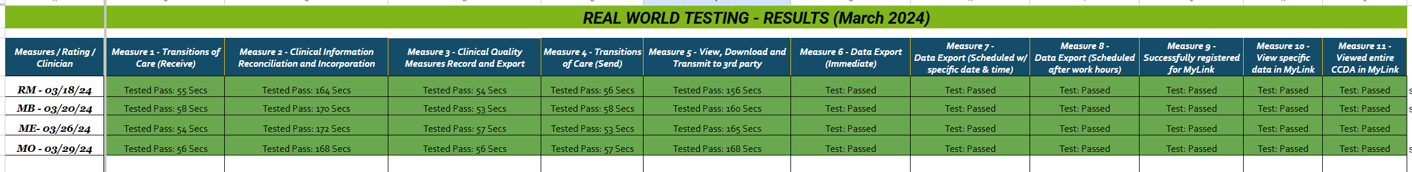

For Quarter 1, 4 Clinicians participated in the Real-world Testing. As listed above the testers were RM, MB, ME and MO. The brief explanation is mentioned as below:

Measure1, 2 and 4: Transition of Care (Receive), Medication Reconciliation and Transition of Care (Send)

- All the 4 testers were able to successfully receive the C-CDA from an external source sent via Direct Protocol.
- The clinicians were able to login to their Kno2 Direct Email account using their unique User ID and Password and retrieved the C-CDA.
- The C-CDA was successfully validated in the ICANotes EHR. After validating the C-CDA, the medication, allergies and diagnosis was successfully reconciled into the note.
- The clinicians signed the note, and they were able to send the updated C-CDA (Transition of care) to an external individual via Direct protocol and also to the patient portal
- The entire steps were completed in the time frame as mentioned above.

Measure 3: Clinical Quality Measures Record and Export

- After reconciling the medications, allergies and diagnosis, all the testers were able to attach a service code For Example: 99203 and easily select the checkbox to indicate the Current Medications were Documented successfully in the note.
- The testers were able to complete the entire steps easily in the time frame mentioned above.

Measure 5: View, Download and Transmit to 3rd Party

- The testers were able to successfully login to Patient Portal using the fake PHI and were able to view, download and transmit the reconciled C-CDA in the timeframe as mentioned above.

Measure 6 to 8: Data Export

- The clinicians accessed the ICANotes upload site and were able to successfully complete the 3 different types of data exports.
- Measure 6 – Data Export (Immediate)
- Measure 7 – Data Export (Scheduled with specific date and time)
- Measure 8 – Data Export (Scheduled after work hours)

Measure 9: Application Access – Patient Selection

- The tester successfully received the registration email for the third-party API software after enabling the feature from the Demographics section of ICANotes.

Measure 10 and 11: Standardized API Criterion and Application Access – All Data Request

- After receiving the registration email, the tester was able to successfully register the fake PHI for the first time and authorized the data access to the 3rd party application
- The tester was able to complete the registration in the MyLinks application and gathered the records successfully
- After gathering the record, the tester was able to generate the authorized user’s completed C-CDA in a human readable format

REPORT AND RESULTS – Q2: June 2024

Expected outcomes for the 11 events will include the following data points:

  - Total number of events tested: 11
  - Number of passed (i.e. successful) events: 11
  - Number of passed and partial completions: 0
  - Number of not tested / incomplete events: 0

As detailed in this plan under the “Schedule of Key Milestones” section, each measure/metric will be tested at least once per quarter with our clinician RWT groups to ensure the expected outcomes are reliably attained.

Measurement/Metric | Report | Result
§ 170.315(b)(1) Transitions of Care (Receive) | A CCDA was sent via Direct Protocol to the Clinicians with a Direct Address and unique Kno2 credentials by an external individual.  The Clinician successfully received the transition of care from the external individual, they carried out the necessary steps and the CCDA was visible in the patient’s chart with no conflict or breach of PHI within the stipulated 60-second time frame. | Tested –  Pass
§ 170.315(b)(2) Clinical Information Reconciliation and Incorporation | After successful receipt of the CCDA, the Clinician validated the CCDA within ICANotes and the clinical information reconciliation for medication, medication allergy, and current problem list was performed. | Tested –  Pass
170.315(c)(1) Clinical Quality Measures Record and Export | CQM was tested and verified within an appropriate location in ICANotes software, within the stipulated 60 seconds.  The following day, CQM report was generated for Documentation of Current Medication and the report showed the patient under the Denominator and the Numerator to indicate we passed this measure. | Tested –  Pass
§ 170.315(b)(1) Transitions of Care (Send) | The Clinician successfully sent the updated CCDA within the 60-second time frame back to the external individual via Direct Protocol and to the patient portal.  The reconciled CCDA was also sent to the Patient Portal. | Tested –  Pass
§ 170.315(e)(1) View,  Download and Transmit to 3rd party | The Clinicians accessed the patient portal using fake PHI and successfully Viewed, Downloaded and Transmitted the reconciled CCDA under the stipulated 3-minute time. | Tested –  Pass

Measurement/Metric | Report | Result
§ 170.315(b)(6) Data Export | The Clinicians accessed the ICANotes Upload Site and successfully did 3 different types of data exports.  Measure 6 – Data Export (Immediate)  Measure 7 – Data Export (Scheduled with specific date and time) Measure 8 – Data Export (Scheduled after work hours)  The exported information was recorded and stored. | Tested –  Pass
§ 170.315(g)(7) Application Access – Patient Selection | The authorized person (patient) successfully received the registration email for the third-party API software after enabling the feature from the Demographics section of ICANotes. | Tested –  Pass
§ 170.315(g)(10)  Application Access –  Standardized API Criterion | The authorized user (Clinician) successfully met the g(10) API criterion in the third-party software by:  - Authenticating and authorizing – 1st time connection  - Establishing a secure and trusted connection  - The user completed the ‘App registration’ with the technology’s “authentication server”  - Conducting search requests for data within the search criteria  Received a data response after requesting data. | Tested –  Pass
§ 170.315(g)(9) Application Access – All Data Request | The third-party software successfully generated the authorized user’s complete CCDA. | Tested –  Pass

Three (3) Clinicians/Practice staff members participated in a single session in which all measures were attempted to be tested.
Overall, we received an averaged “Pass” status for 11 of the 11 measures that were tested by three different testers involved which synthesized the individual assessments into a unified result.

Synopsis of the Measures that were successfully Tested in Q2.

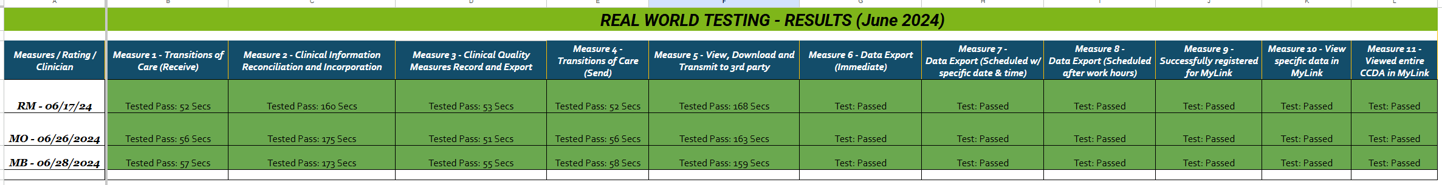

For Quarter 2, 3 Clinicians participated in the Real-world Testing. As listed above the testers were RM, MO and MB. The brief explanation is mentioned as below:

Measure1, 2 and 4: Transition of Care (Receive), Medication Reconciliation and Transition of Care (Send)

- All the 3 testers were able to successfully receive the C-CDA from an external source sent via Direct Protocol.
- The clinicians were able to login to their Kno2 Direct Email account using their unique User ID and Password and retrieved the C-CDA.
- The C-CDA was successfully validated in the ICANotes EHR. After validating the C-CDA, the medication, allergies and diagnosis was successfully reconciled into the note.
- The clinicians signed the note, and they were able to send the updated C-CDA (Transition of care) to an external individual via Direct protocol and also to the patient portal
- The entire steps were completed in the time frame as mentioned above.

Measure 3: Clinical Quality Measures Record and Export

- After reconciling the medications, allergies and diagnosis, all the testers were able to attach a service code For Example: 99203 and easily select the checkbox to indicate the Current Medications were Documented successfully in the note.
- The testers were able to complete the entire steps easily in the time frame mentioned above.

Measure 5: View, Download and Transmit to 3rd Party

- The testers were able to successfully login to Patient Portal using the fake PHI and were able to view, download and transmit the reconciled C-CDA in the timeframe as mentioned above.

Measure 6 to 8: Data Export

- The clinicians accessed the ICANotes upload site and were able to successfully complete the 3 different types of data exports.
- Measure 6 – Data Export (Immediate)
- Measure 7 – Data Export (Scheduled with specific date and time)
- Measure 8 – Data Export (Scheduled after work hours)

Measure 9: Application Access – Patient Selection

- The tester successfully received the registration email for the third-party API software after enabling the feature from the Demographics section of ICANotes.

Measure 10 and 11: Standardized API Criterion and Application Access – All Data Request

- After receiving the registration email, the tester was able to successfully register the fake PHI for the first time and authorized the data access to the 3rd party application
- The tester was able to complete the registration in the MyLinks application and gathered the records successfully
- After gathering the record, the tester was able to generate the authorized user’s completed C-CDA in a human readable format

REPORT AND RESULTS – Q3: September 2024

Expected outcomes for the 11 events will include the following data points:

  - Total number of events tested: 11
  - Number of passed (i.e. successful) events: 11
  - Number of passed and partial completions: 0
  - Number of not tested / incomplete events: 0
As detailed in this plan under the “Schedule of Key Milestones” section, each measure/metric will be tested at least once per quarter with our clinician RWT groups to ensure the expected outcomes are reliably attained.

Measurement/Metric | Report | Result
§ 170.315(b)(1) Transitions of Care (Receive) – 60 seconds. | A CCDA was sent via Direct Protocol to the Clinicians with a Direct Address and unique Kno2 credentials by an external individual.  The Clinician successfully received the transition of care from the external individual, they carried out the necessary steps and the CCDA was visible in the patient’s chart with no conflict or breach of PHI within the stipulated 60-second time frame. | Tested –  Pass
§ 170.315(b)(2) Clinical Information Reconciliation and Incorporation – 180 seconds | After successful receipt of the CCDA, the Clinician validated it within ICANotes.  They successfully reconciled the medication, medication allergy, and current problem list using the ICANotes software within the stipulated time of 180 seconds. | Tested –  Pass
170.315(c)(1) Clinical Quality Measures Record and Export – 60 seconds | CQM was tested and verified within an appropriate location in ICANotes software, within the stipulated 60 seconds.  The following day, CQM report was generated for Documentation of Current Medication and the report showed the patient under the Denominator and the Numerator to indicate we passed this measure. | Tested –  Pass
§ 170.315(b)(1) Transitions of Care (Send) – 60 seconds | The Clinician sent the updated CCDA with minimal delay back to the external individual via Direct Protocol within the stipulated 60 seconds.  The reconciled CCDA was also sent to the Patient | Tested –  Pass
§ 170.315(e)(1) View,  Download and Transmit to 3rd party – 3 minutes | The Clinicians accessed the patient portal using fake PHI and successfully Viewed, Downloaded and Transmitted the reconciled CCDA under the stipulated 3-minute time. | Tested –  Pass

Measurement/Metric | Report | Result
§ 170.315(b)(6) Data Export | The Clinicians accessed the ICANotes Upload Site and successfully did 3 different types of data exports.  Measure 6 – Data Export (Immediate)  Measure 7 – Data Export (Scheduled with specific date and time) Measure 8 – Data Export (Scheduled after work hours)  The exported information was recorded and stored. | Tested –  Pass
§ 170.315(g)(7) Application Access – Patient Selection | The authorized person (patient) successfully received the registration email for the third-party API software after enabling the feature from the Demographics section of ICANotes. | Tested –  Pass
§ 170.315(g)(10)  Application Access –  Standardized API Criterion | The authorized user (Clinician) successfully met the g(10) API criterion in the third-party software by:  - Authenticating and authorizing – 1st time connection  - Establishing a secure and trusted connection  - The user completed the ‘App registration’ with the technology’s “authentication server”  - Conducting search requests for data within the search criteria  - Received a data response after requesting data. | Tested –  Pass
§ 170.315(g)(9) Application Access – All Data Request | The third-party software successfully generated the authorized user’s complete CCDA. | Tested –  Pass
Two (2) Clinicians/Practice staff members participated in a single session in which all measures were attempted to be tested.
Overall, an averaged “Pass” status was achieved for all 11 measures tested by two different testers involved which synthesized the individual assessments into a unified result.

Synopsis of the Measures that were successfully Tested in Q3.
Real-World Test Plan | 01/15/2024

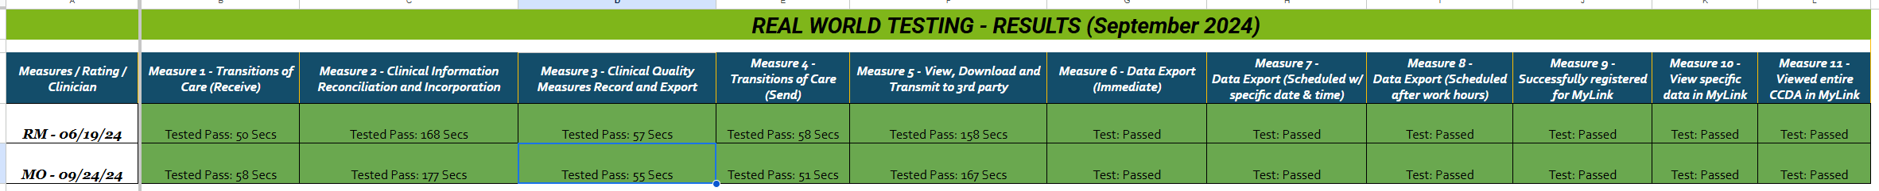

For Quarter 3, 2 Clinicians participated in the Real-World Testing. As listed above the testers were RM and MO. The brief explanation is mentioned as below:

Measure1, 2 and 4: Transition of Care (Receive), Medication Reconciliation and Transition of Care (Send)

- The 2 testers were able to successfully receive the C-CDA from an external source sent via Direct Protocol.
- The clinicians were able to login to their Kno2 Direct Email account using their unique User ID and Password and retrieved the C-CDA.
- The C-CDA was successfully validated in the ICANotes EHR. After validating the C-CDA, the medication, allergies and diagnosis was successfully reconciled into the note.
- The clinicians signed the note, and they were able to send the updated C-CDA (Transition of care) to an external individual via Direct protocol and also to the patient portal
- The entire steps were completed in the time frame as mentioned above.

Measure 3: Clinical Quality Measures Record and Export

- After reconciling the medications, allergies and diagnosis, all the testers were able to attach a service code For Example: 99203 and easily select the checkbox to indicate the Current Medications were Documented successfully in the note.
- The testers were able to complete the entire steps easily in the time frame mentioned above.

Measure 5: View, Download and Transmit to 3rd Party

- The testers were able to successfully login to Patient Portal using the fake PHI and were able to view, download and transmit the reconciled C-CDA in the timeframe as mentioned above.

Measure 6 to 8: Data Export

- The clinicians accessed the ICANotes upload site and were able to successfully complete the 3 different types of data exports.
- Measure 6 – Data Export (Immediate)
- Measure 7 – Data Export (Scheduled with specific date and time)
- Measure 8 – Data Export (Scheduled after work hours)

Measure 9: Application Access – Patient Selection

- The tester successfully received the registration email for the third-party API software after enabling the feature from the Demographics section of ICANotes.

Measure 10 and 11: Standardized API Criterion and Application Access – All Data Request

- After receiving the registration email, the tester was able to successfully register the fake PHI for the first time and authorized the data access to the 3rd party application
- The tester was able to complete the registration in the MyLinks application and gathered the records successfully
- After gathering the record, the tester was able to generate the authorized user’s completed C-CDA in a human readable format

REPORT AND RESULTS – Q4: December 2024

Expected outcomes for the 11 events will include the following data points:

  - Total number of events tested: 11
  - Number of passed (i.e. successful) events: 11
  - Number of passed and partial completions: 0
  - Number of not tested / incomplete events: 0

As detailed in this plan under the “Schedule of Key Milestones” section, each measure/metric will be tested at least once per quarter with our clinician RWT groups to ensure the expected outcomes are reliably attained.

Measurement/Metric | Report | Result
§ 170.315(b)(1) Transitions of Care (Receive) – 60 seconds. | PHI was de-sensitized by the Clinicians and the replication of the de-sensitized information was done by an external individual. A CCDA was sent via Direct Protocol to the Clinicians with a Direct Address and unique Kno2 credentials.  The restriction that was encountered in Q1 and Q2 was resolved in time for Q3 and Q4 by using a certified Clinician (external provider) who has a Kno2 production account.  The Clinician successfully received the CCDA within the stipulated time of 60 seconds. | Tested –  Pass
§ 170.315(b)(2) Clinical Information Reconciliation and Incorporation – 180 seconds | After successful receipt of the CCDA, the Clinician validated it within ICANotes.  They successfully reconciled the medication, medication allergy, and current problem list using the ICANotes software within the stipulated time of 180 seconds. | Tested –  Pass
170.315(c)(1) Clinical Quality Measures Record and Export – 60 seconds | CQM was tested and verified within an appropriate location in ICANotes software, within the stipulated 60 seconds.  The following day, CQM report was generated for Documentation of Current Medication and the report showed the patient under the Denominator and the Numerator to indicate we passed this measure. | Tested –  Pass
§ 170.315(b)(1) Transitions of Care (Send) – 60 seconds | The Clinician sent the updated CCDA with minimal delay back to the external individual via Direct Protocol within the stipulated 60 seconds.  The reconciled CCDA was also sent to Patient Portal. | Tested –  Pass

Measurement/Metric | Report | Result
§ 170.315(e)(1) View,  Download and Transmit to 3rd party – 3 minutes | The Clinicians accessed the patient portal using fake PHI and successfully Viewed, Downloaded and Transmitted the reconciled CCDA under the stipulated 3-minute time. | Tested –  Pass
§ 170.315(b)(6) Data Export | The Clinicians accessed the ICANotes Upload Site and successfully did 3 different types of data exports.  Measure 6 – Data Export (Immediate)  Measure 7 – Data Export (Scheduled with specific date and time) Measure 8 – Data Export (Scheduled after work hours)  The exported information was recorded and stored. | Tested –  Pass
§ 170.315(g)(7) Application Access – Patient Selection | The authorized person (patient) successfully received the registration email for the third-party API software after enabling the feature from the Demographics section of ICANotes. | Tested –  Pass
§ 170.315(g)(10)  Application Access –  Standardized API Criterion | The authorized user (Clinician) successfully met the g(10) API criterion in the third-party software by:  - Authenticating and authorizing – 1st time connection  - Establishing a secure and trusted connection  - The user completed the ‘App registration’ with the technology’s “authentication server”  - Conducting search requests for data within the search criteria  - Received a data response after requesting data. | Tested –  Pass
§ 170.315(g)(9) Application Access – All Data Request | The third-party software successfully generated the authorized user’s complete CCDA. | Tested –  Pass
Two (2) Clinicians/Practice staff members and an internal tester participated in a single session in which all measures were attempted to be tested.
Overall, an averaged “Pass” status was achieved for all 11 measures tested by 1 Clinician (MB)
1 Internal Tester (JA) tested 8 measures successfully and couldn’t test 3 measures linked to Kno2
1 Clinician (AT) tested 5 measures successfully, but couldn’t test 3 measures linked with Kno2 and 3 measures were incompletely tested that are linked with API and data access to the Third-party application (My Links).

Synopsis of the Measures that were Not Tested or Tested- incomplete in Q4

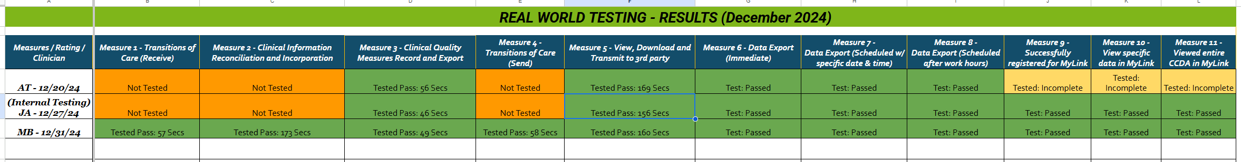

Not Tested: Measure 1, 2 and 4 – Kno2 credential error:
The Clinician (AT) and Internal tester (JA) were unable to test Measures 1, 2, and 4 due to the lack of access to their Kno2 account. This prevented the clinician from interacting with the platform, directly impacting the ability to test these measures.
Tested - Incomplete:
Measure 9 – DHIT FHIR restriction:
The Clinician (AT) was unable to complete the testing for Measure 9 due to a MyLink registration issue, said issue hindered the entire registration and verification process. The registration process was completed with the third-party system MyLink, and we also received the confirmation for the same. During the testing the registration email listed an incorrect Practice name and also didn’t include the MyLink system URL to complete the registration.
Measure 10 and 11 – DHIT FHIR restriction:
The Clinician (AT) was unable to complete Measure 10 because of a technical issue on the MyLink site disallowing data to be viewed which in turn affected the testing of Measure 11. The registration issue we faced for measure 9 also hampered our testing for Measure 10 and 11 for the clinician (AT).
Due to the registration issue, we were unable to authorize the PHI access to the MyLinks and we were not able to Gather Records and export the completed C-CDA into human readable format. Since the MyLinks is a third-party system and as we have to depend on their support to rectify the issue, we were not able to complete the testing for Measure 9, 10 and 11.
To ensure that we resolve this issue for future testing, we are working with the third party API software and MyLinks support to resolve the registration issue by re-verifying the entire process to ensure that the accurate practice details gets registered for FHIR API and also verify with MyLinks that the issue with Gathering Records is resolved.

This image indicates the error we faced while testing Measure 9
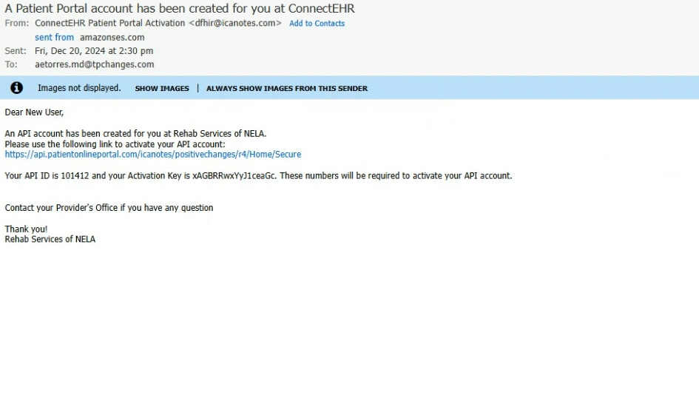

This image indicates the error we faced while testing Measures 10 and 11
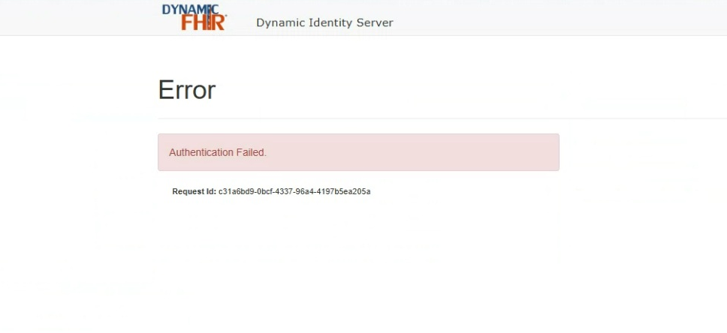

Screenshots for measures tested successfully.

Measure 1: Transitions of Care (Receive)

This image indicates that the tester was able to successfully receive the C-CDA from an external individual as Transition of Care using Direct protocol.

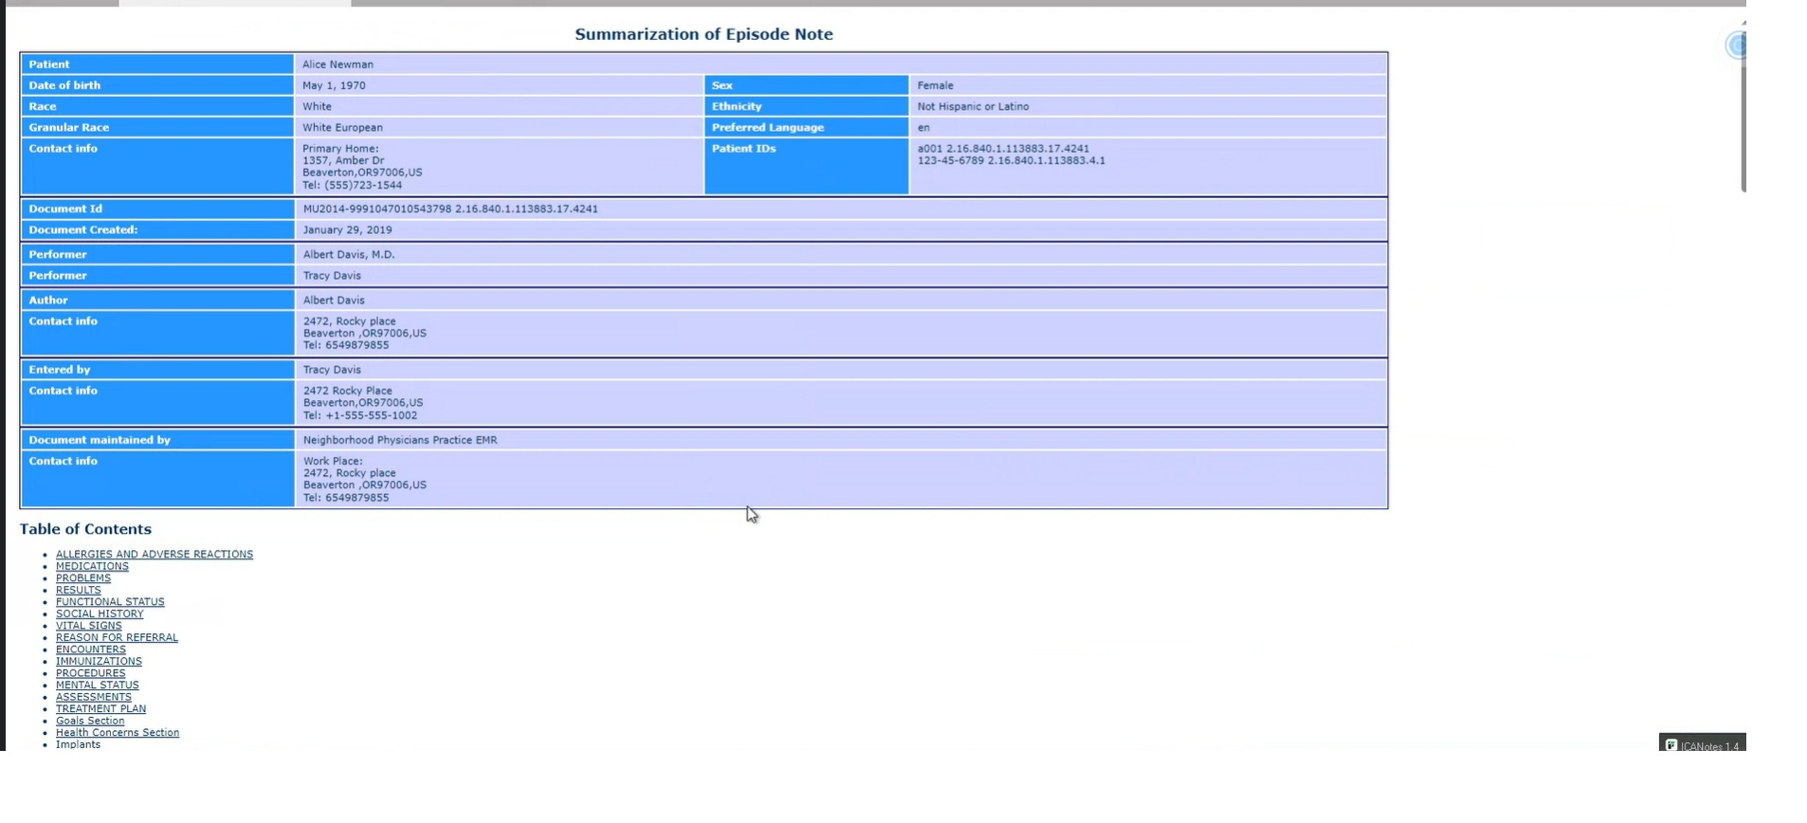

Measure 2: Clinical Information Reconciliation and Incorporation

This image indicates that the C-CDA received by the tester via Direct protocol was successfully validated in ICANotes EHR.

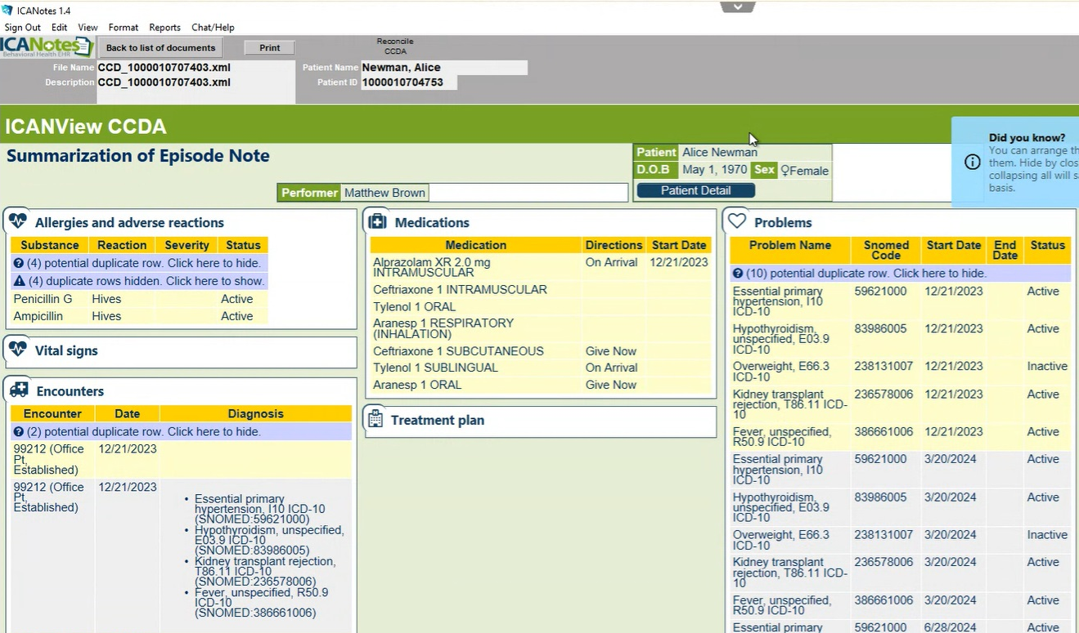

The images below indicate that after successfully validating the C-CDA in ICANotes, the Medication and Allergies were successfully reconciled in the note

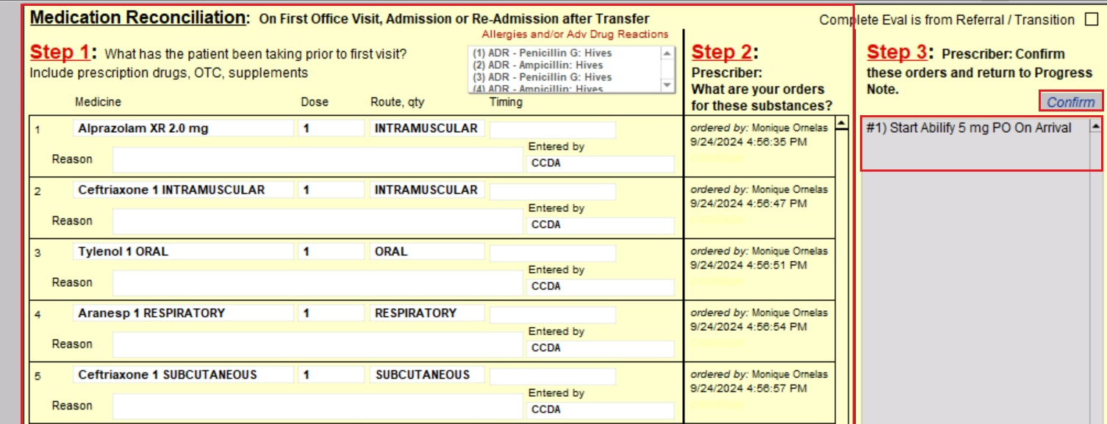

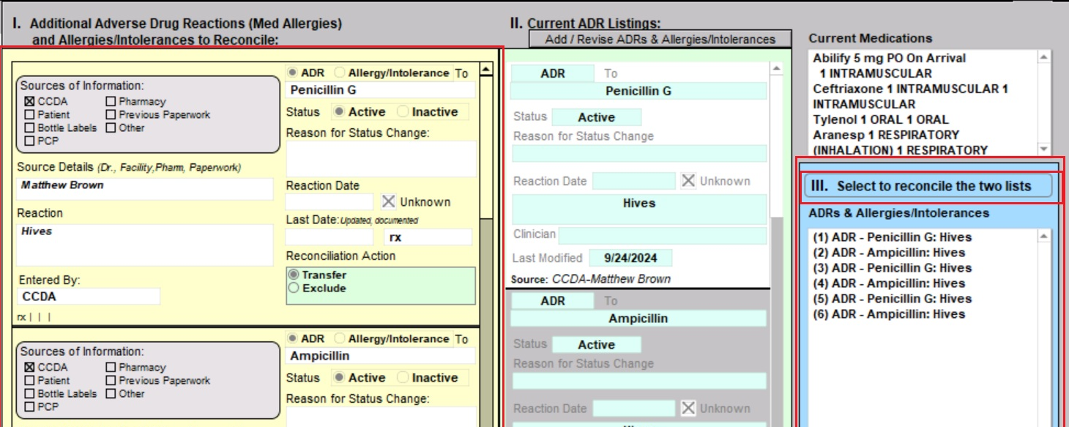

The image below indicate that the tester was able to successfully reconcile the diagnosis in the note.

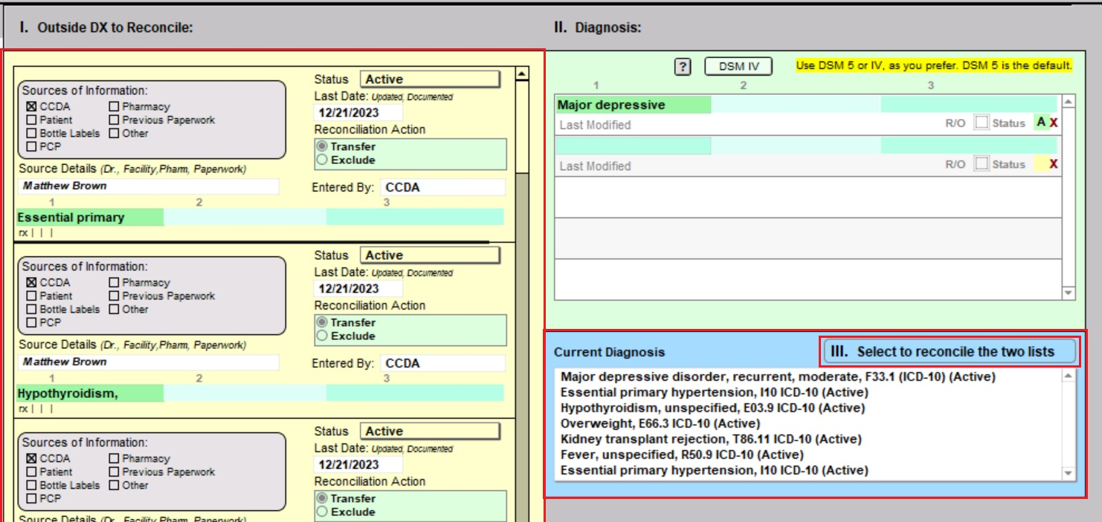

Measure 3: Clinical Quality Measures Record

The image indicates that the tester was able to successfully click the checkbox for “Rx Medication Review Done” for Documentation of Current Medication eCQM

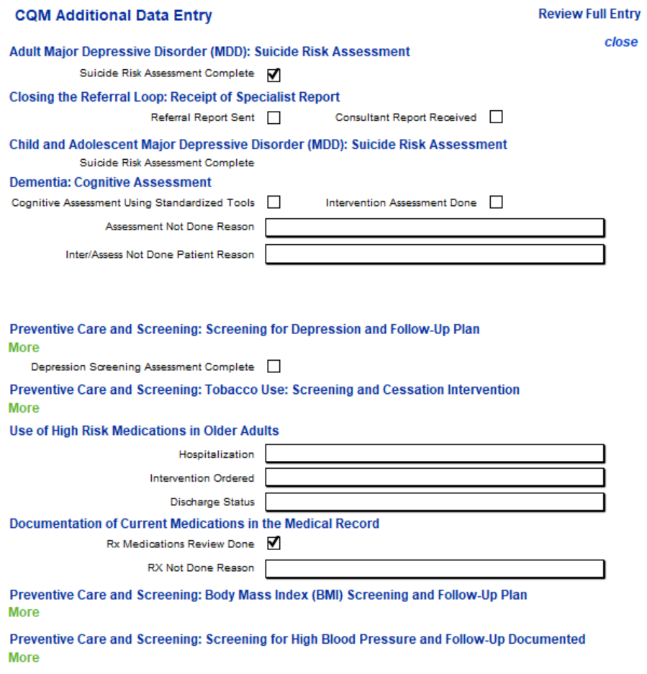

This image indicates the Documentation of Current Medication eCQM report with patient listed under Initial Patient Population and Denominator

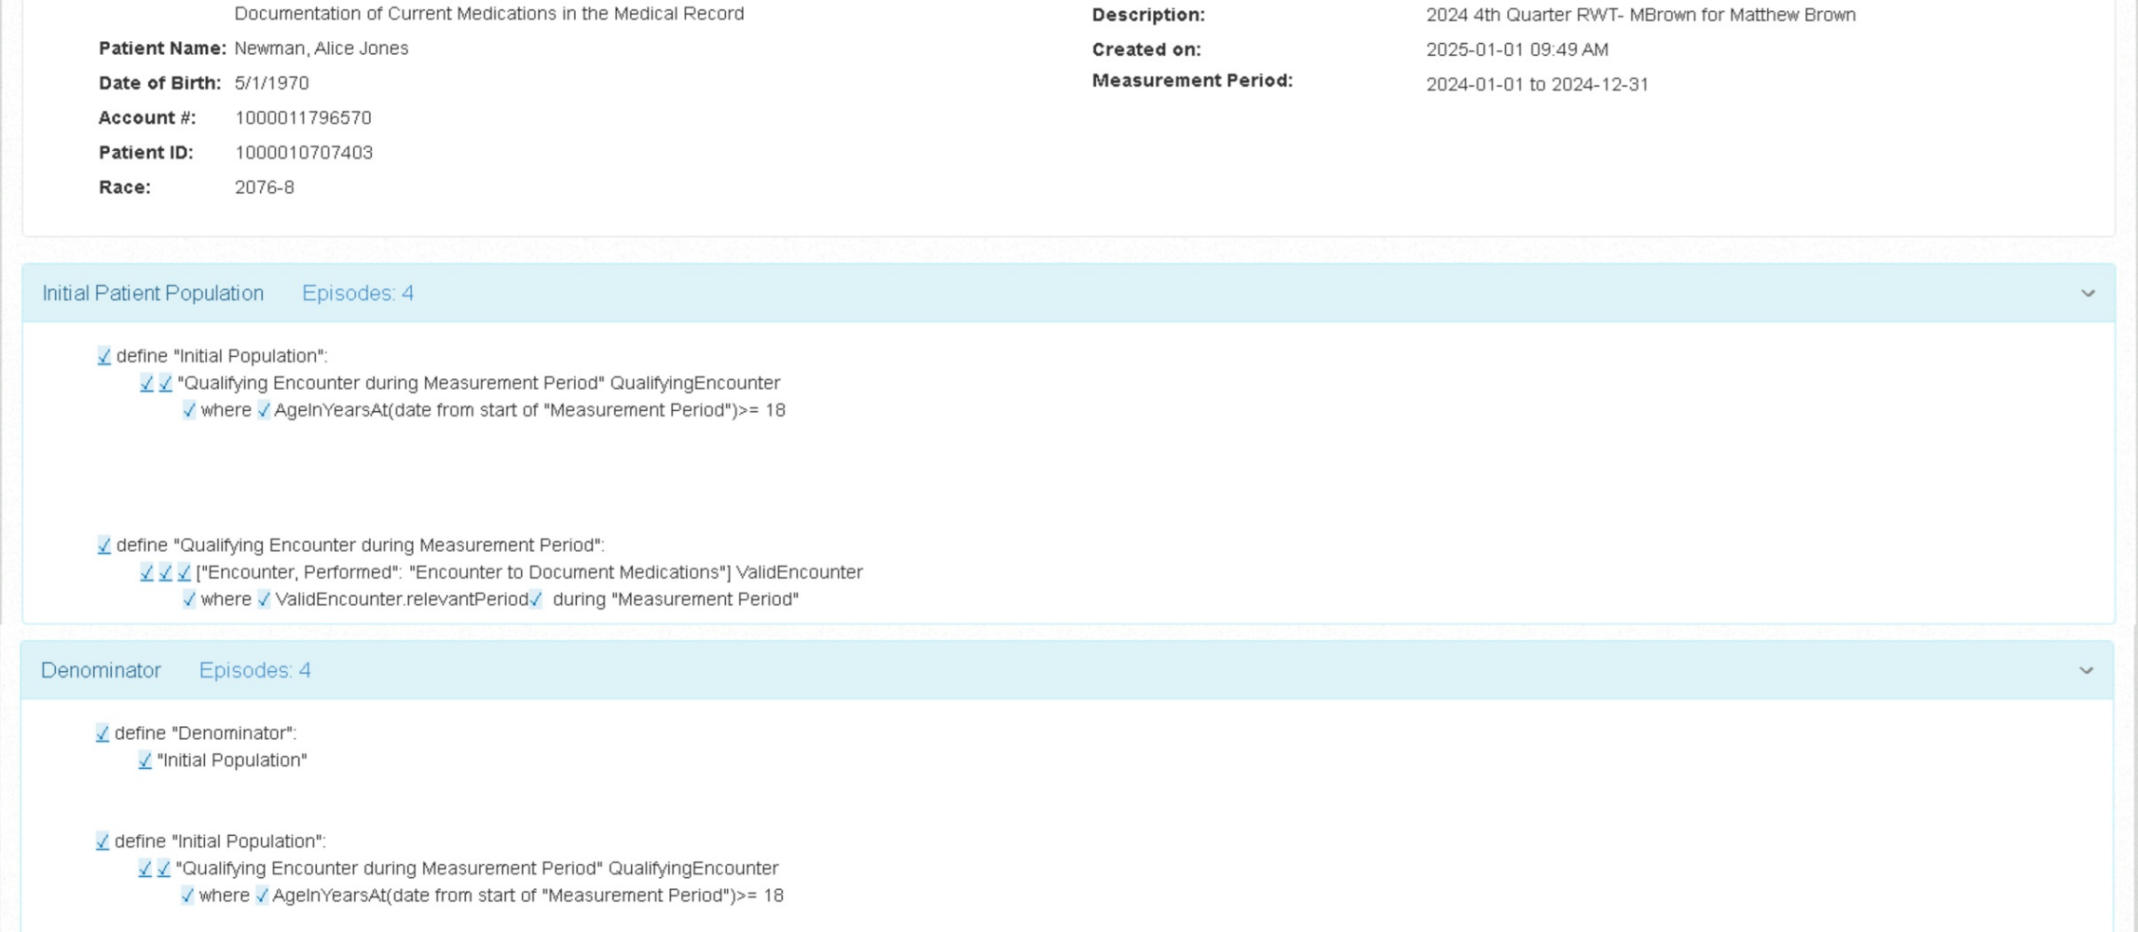

This image indicates that the patient is also listed under the Numerator and also lists the patient’s name and the service code used in the note by the clinician

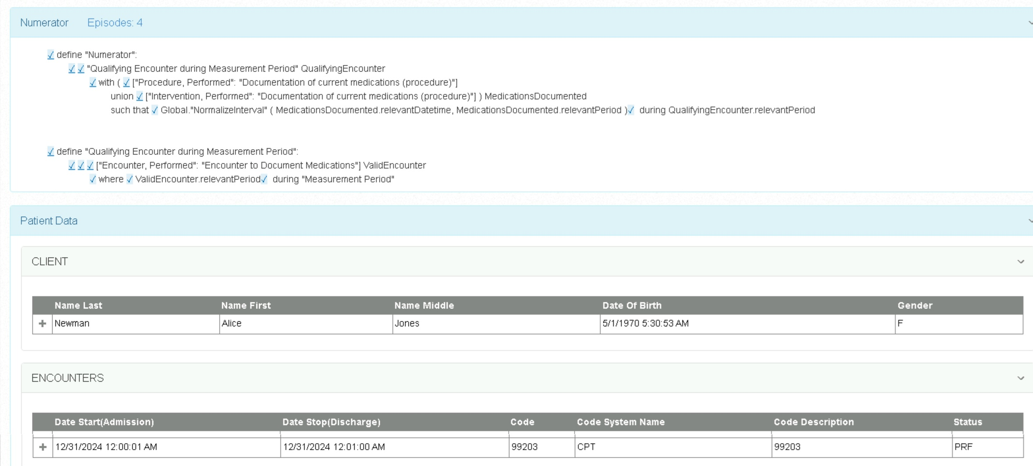

This image indicates the medication reconciled in the note and also indicates the SNOMED code used for Documentation of Current Medication eCQM.

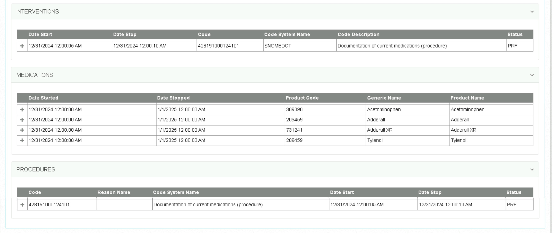

Measure 5: View, Download and Transmit to 3rd party

This image indicates that the patient can view their medical record of their visit on the patient portal.

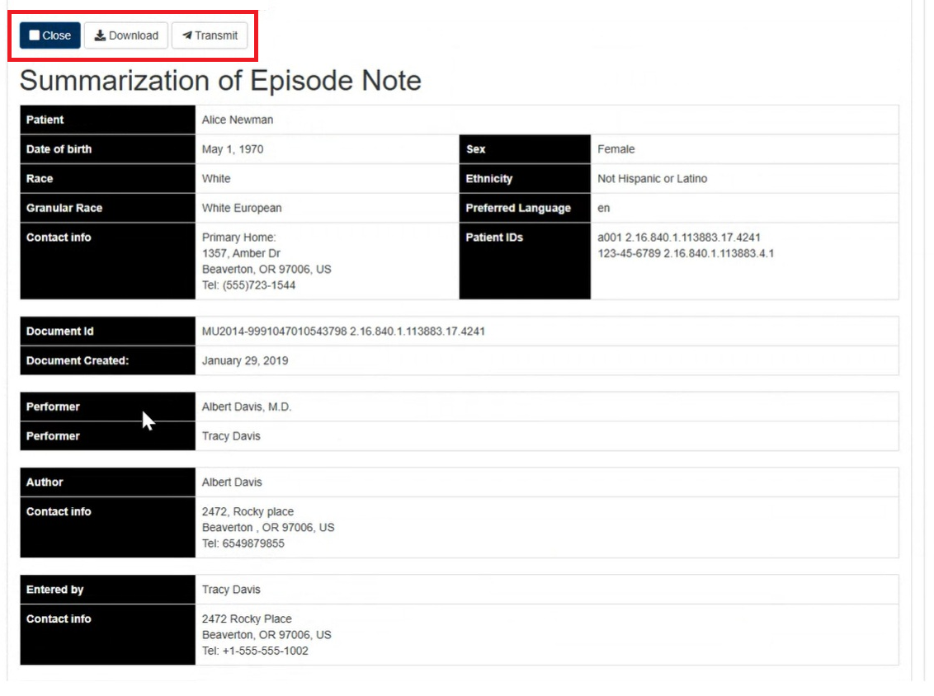

This image indicates that the patient can download their medical record to their local device from the patient portal.

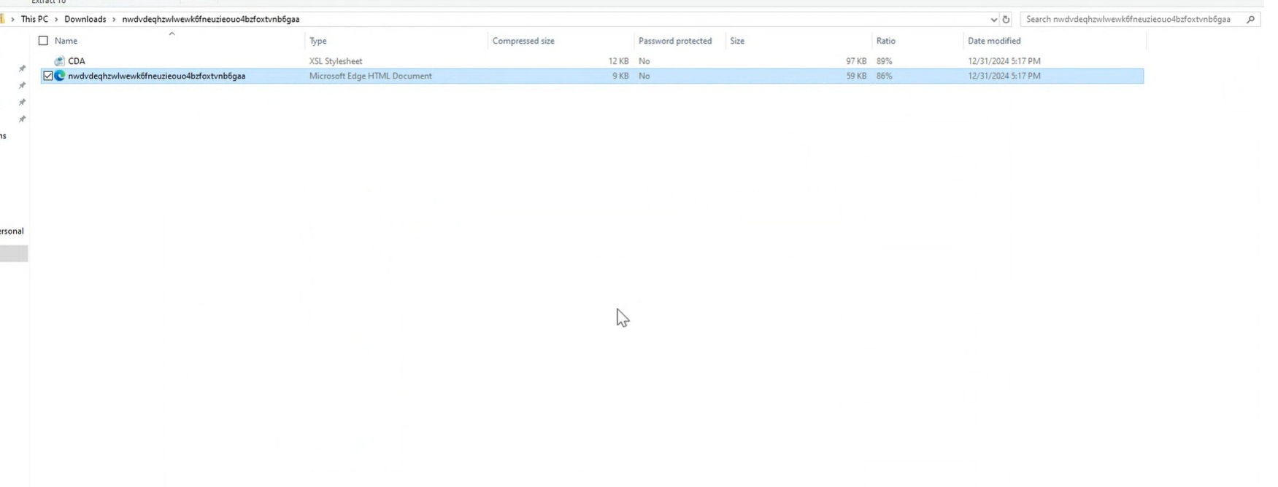

This image indicates that the patient can transmit their medical records to an email securely from the patient portal

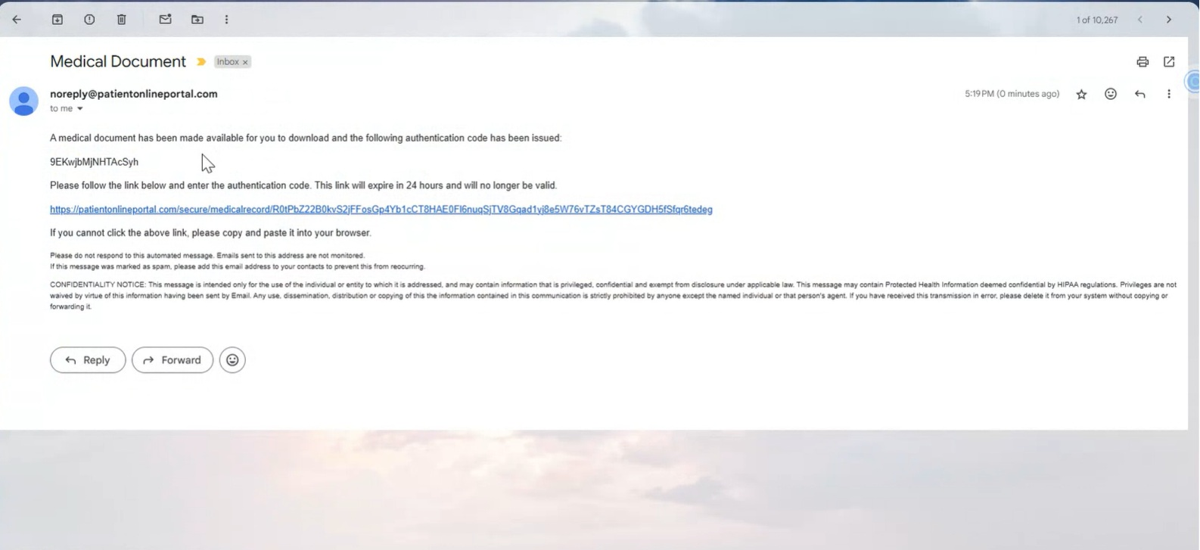

Measure 6 - 8: Data Export

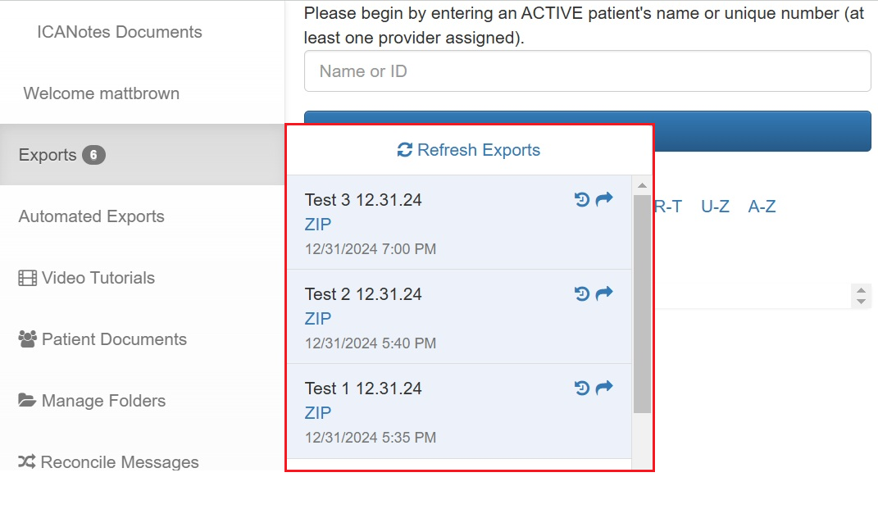

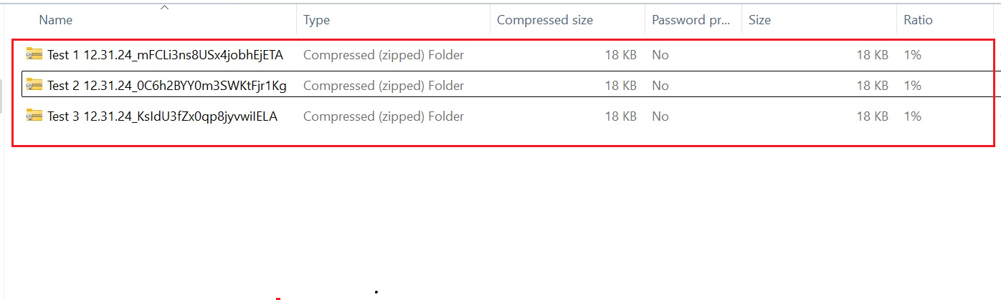

The image above displays the requested exports for Measures 6 through 8.

1.“record”: Measure 6 – Data Export (Immediate)
2.“record required”: Measure 7 – Data Export (Scheduled with specific date and time)
3.“record required2”: Measure 8 – Data Export (Scheduled after work hours)

Measure 9: Application Access – Patient Selection

This image indicates the details sent to the patient’s email with their credentials to activate the API access to receive their health record

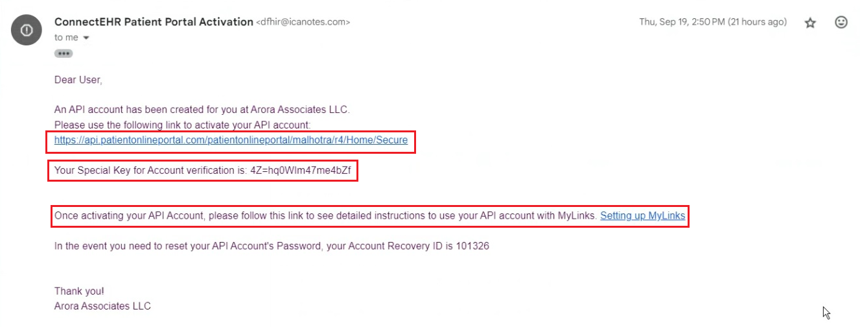

Measure 10: Application Access- Standardized API Criterion

This image indicates the patient can search for their clinician’s practice name after authenticating and completing their registration on the HIPAA-certified 3rd party application (MyLinks) to download their health records. After selecting the practice name, the patient can Gather Records from the 3rd party application (MyLinks)

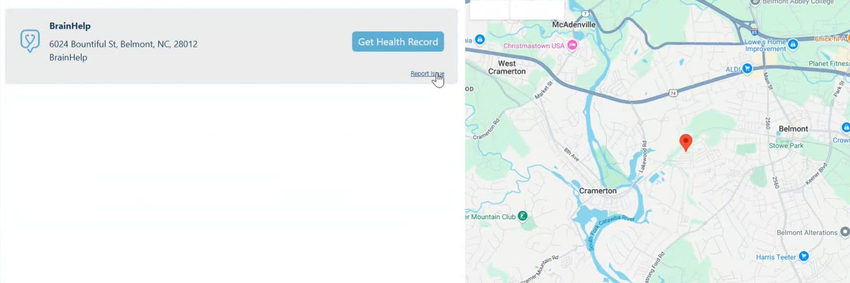

Measure 11: Application Access – All Data Request

This image indicates that the patient can gather their Health Records from a third-party application and convert it into a human-readable format like pdf.

